  - Displacement of Civilians and the Efficacy of IHL
1:30PM EST | Welcome and Opening Remarks (Bilingual, 10 minutes) | Marco Fiola  Principal of Glendon Campus of York University  Master of Ceremony: Craig M. Scott Associate Dean (Academic) of Osgoode (York University)
1:40PM EST | Session 1: Introduction to International Humanitarian Law (IHL) (In French, 25 minutes)  Q&A (10 minutes) | Sophie Rondeau  Senior Legal Advisor, IHL, Canadian Red Cross
2:20PM EST | Break (10 minutes)
2:30PM EST | Session 2: Warfare, Displacement and the Efficacy of IHL (Bilingual, 25 minutes)  Q&A (10 minutes) | Moderator: Joanna L. Robinson, Interim Director, Glendon School of Public and International Affairs (York University)  Sarah Khan  Former Senior Protection Officer of UNHCR; Research LLM candidate, Osgoode Hall Law School/ Graduate Scholar, Dahdaleh Institute for Global Health Research  Ndeye Dieynaba Ndiaye  Professor of migration law in the Department of Legal Sciences, UQAM | University of Quebec in Montreal
3:05PM EST | Break (10 minutes)
3:15PM EST | Session 3: Interface of Conflict and Climate Change Migration (In English, 25 minutes)  Q&A (10 minutes) | Saptarishi Bandopadhyay  Assistant Professor of Law, Osgoode Hall Law School and author of ‘All is Well’  Rachel Laut  Author of Humans on the Move: Integrating an Adaptive Approach with a Rights-Based Approach to Climate Change Mobility
3:55PM EST | Closing Remarks (5 minutes)  Evaluation | Fatimah Al-Toum  IHL Coordinator, Canadian Red Cross
4:00PM EST | END

Sophie Rondeau is currently the Senior Legal Advisor, International Humanitarian Law, at the Canadian Red Cross. She holds an LL. B (UdeM), an LL.M (international law, UQAM) and an LL.D (UNIGE/ ULaval). Dr. Rondeau is a member of the Quebec Bar, a lecturer at Université Sherbrooke, and an associate member of the Canadian observatory on humanitarian crisis and action (OOCAH). Over the years, she worked in the field of international humanitarian law, international justice and international human rights in organizations such as the Diakonia IHL Center, Rights and Democracy, the Canadian Red Cross, the Jean-Pictet Competition and the ICTY.

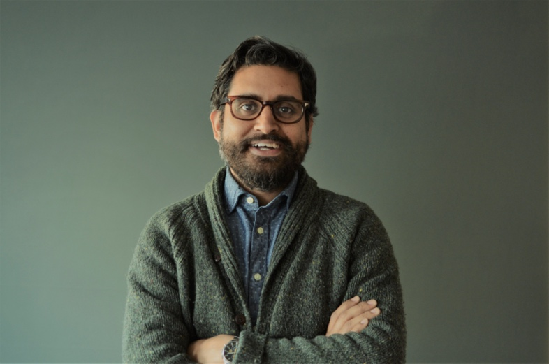
Saptarishi Bandopadhyay is an Assistant Professor at Osgoode Hall Law School, York University. He holds a doctorate from Harvard University, master’s degrees from Harvard Law School and American University, and received his formal legal training at the National University of Juridical Sciences in India. Saptarishi’s first book, All Is Well: Catastrophe and the Making of the Normal State was published by Oxford University Press in 2022. Saptarishi has studied and worked in disaster management in central India, in the borderlands between India, Pakistan, and China, and in the Philippines. He has trained and advised officials and civil society in India, Thailand, and Canada and has published widely on disaster risk, international law, and related areas. Saptarishi has received research and advocacy grants and fellowships from the Canadian Social Sciences and Humanities Research Council, Harvard University, the Public International Law and Policy Group, the Center for International Environmental Law, Brown University's Watson Institute for International Studies, York University's Dahdaleh Institute for Global Health Research, and the Berkman-Klein Center for Internet & Society, among other institutions. His current research studies the historical and contemporary relationship between war/armed conflict, environmental crises, and human displacement.

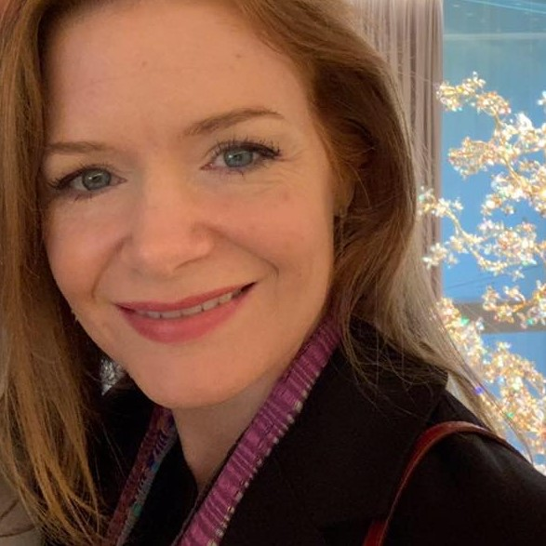
Rachel Laut, J.D., Harvard Law School, has practiced in private and public international law. A member of the New York Bar, she has authored and contributed to several publications on international law. Her most recent publication is the book Humans on the Move: Integrating an Adaptive Approach with a Rights-Based Approach to Climate Change Mobility.

Sarah Khan, BA LLB (Hons.), MA
Global Health Scholar
Research Team
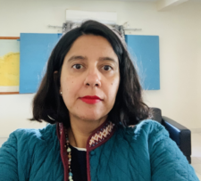
Sarah has worked for over 12 years with the United Nations High Commissioner for Refugees (UNHCR) on the international protection of human rights and on refugee and international humanitarian law in displacement contexts of conflict/post-conflict and natural disasters. She has supported the development of protection policies for UN/NGO humanitarian country teams; assisted governments with the development of IDP legislation/policy; designed capacity-building programs on international protection and displacement for armed actors and civil society; developed protection monitoring systems for response and advocacy, and coordinated UN/NGO actors on inter-agency protection platforms.
She has worked as a senior protection officer and senior protection cluster coordinator with UNHCR. Her last position was as head of office in Northern Somalia, managing a multifaceted program covering refugees, internally displaced persons (IDPs), and persons in mixed flows (refugees/migrants). She has also worked with NGOs—namely, Oxfam, CAFOD UK, and the Pearson Peacekeeping Centre—where she facilitated integrated training courses for NATO/ISAF and UN Mission senior commanders.
Sarah has lived and worked in Asia, Africa, Europe, and the Middle East, covering various displacement situations, including in Afghanistan, Libya, Myanmar, Somalia, Sudan, and Syria. She has also worked at UNHCR Headquarters in the Global Protection Cluster covering various internal displacement situations, such as those in the Central African Republic, Colombia, Iraq, and the Philippines.
She is a lawyer by training, with a BA LLB Hons. degree from the National Law School at India University and a master of arts in law and diplomacy (MALD) from the Fletcher School of Law and Diplomacy at Tufts University.
Sarah is excited to apply her extensive field operations practice to research as an LLM research student at Osgoode Hall Law School and as a Global Health Graduate Scholar at the Dahdaleh Institute. Her year-long research will focus on the 2016 NATO Policy for the Protection of Civilians and the prevention of displacement as a key consideration for protecting civilians in contemporary conflicts and complex emergencies.

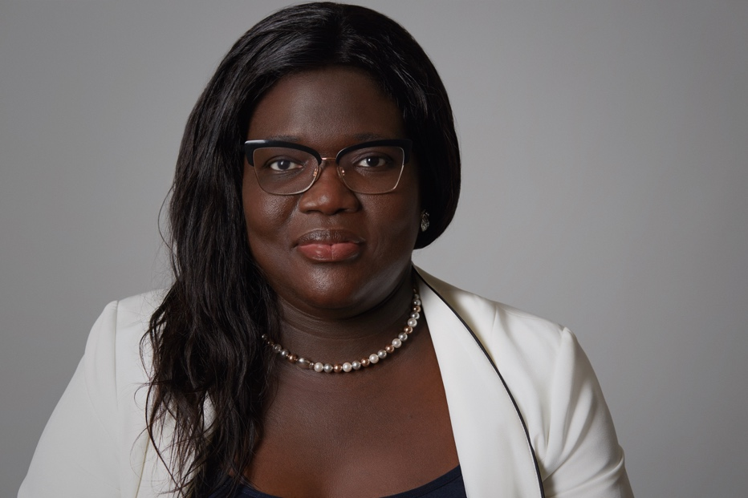
Ndeye Dieynaba Ndiaye is a professor in the Department of Legal Sciences at UQAM. She specializes in Canadian, Quebec and international migration law, international refugee law, European Union law, international labor law and universal and regional human rights systems, African refugee law and migration, and ultimately in the law of foreigners from France, Italy, Morocco and Senegal. Professor Ndiaye is a graduate of Laval University, with Doctorate degree in Laws LL. D, a DESS in fundamental rights from Laval University, a master's degree in European and international fundamental rights law from the University of Nantes and a master's degree in business law from Cheikh Anta Diop University. She created an Observatory on International Migration, Refugees, Stateless Persons and Asylum (OMIRAS) affiliated with IEIM (UQAM). The purpose of this platform, which she leads, is to set up an innovative participation of a multidisciplinary team in the search for sustainable solutions on the mobility of people from the Global South to the Global North. OMIRAS makes it possible to establish a dialogue and multidisciplinary collaborations between young researchers from the North and the South in order to develop research on a balanced and sustainable management of international migration. Her research focuses on the outsourcing of the European fight against irregular migration to third countries which she conceptualized in her doctoral thesis in law, on bilateral and multilateral cooperation between countries of origin, transit and destination, of migration, on securing borders in the management of personal mobility (FRONTEX), the consequences of immigration security policies on the human rights of migrants and the interactions between trafficking in persons, smuggling of migrants and the fight against irregular migration. A specialist in these issues recognized both in Canada and abroad, she has published numerous articles and made several communications, conferences and symposiums on the mobility of migrants and refugees (Africa, Canada and Europe).

Some relevant resources for advance reading:
General on “internally displaced persons”:
ICRC, “Internally displaced persons”
UNHCR, Handbook for the Protection of Internally Displaced Persons
UNHCHR, “About internally displaced persons”
Displacement versus Reverberating Effects:
ICRC, Displacement in times of armed conflict: How international humanitarian law protects in war, and why it matters
Clark Orr, “Reverberating Effects and International Law”
Policy for the Protection of Civilians, North Atlantic Treaty Organization (NATO), 09 July 2016, https://www.nato.int/cps/en/natohq/official_texts_133945.htm
Displacement, Conflict of Climate Change
ICRC, “Climate change and conflict: Impact in displacement”
ICRC, “ICRC to UN Security Council: Double impact of climate change and armed conflict harms people’s ability to cope”

Special Rapport on the human rights of internally displaced persons, Report on internal displacement in the context of the slow-onset adverse effects of climate change

